University of Technology, Jamaica
School of Computing and Information Technology CNS3005: Ethical Hacking
Lecturer: Kevin Johnson
Mekhi Bentley (2304855)
Lab 5

Exploiting Port 22 SSH

- Searching for the right SSH login module in metasploit
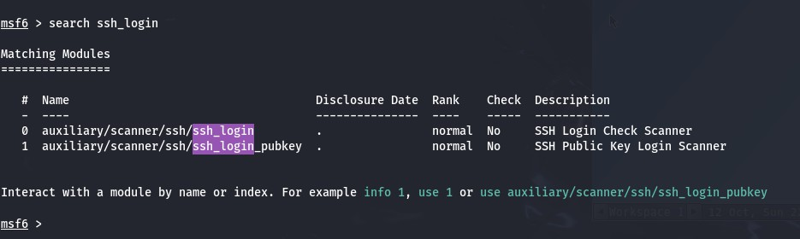

- Setting the target IP address

- Specifying which files Metasploit should use for usernames and passwords to try.
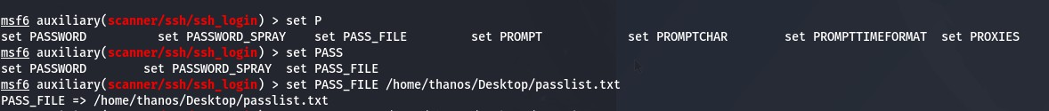

- Running the Brute-Force Attack
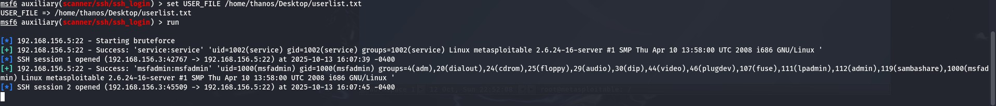

- Upgrading the simple shell session to a Meterpreter session within Metasploit
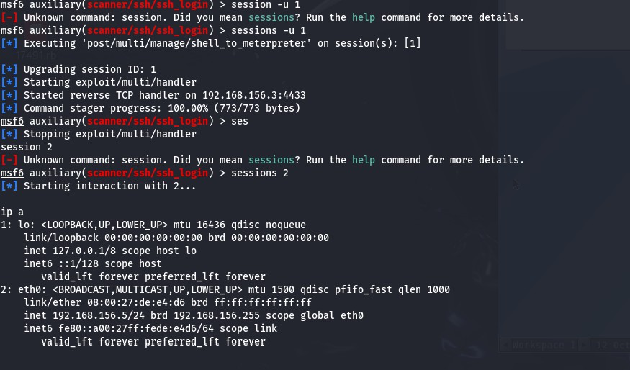

- Conducting a SSH brute force using an Nmap script
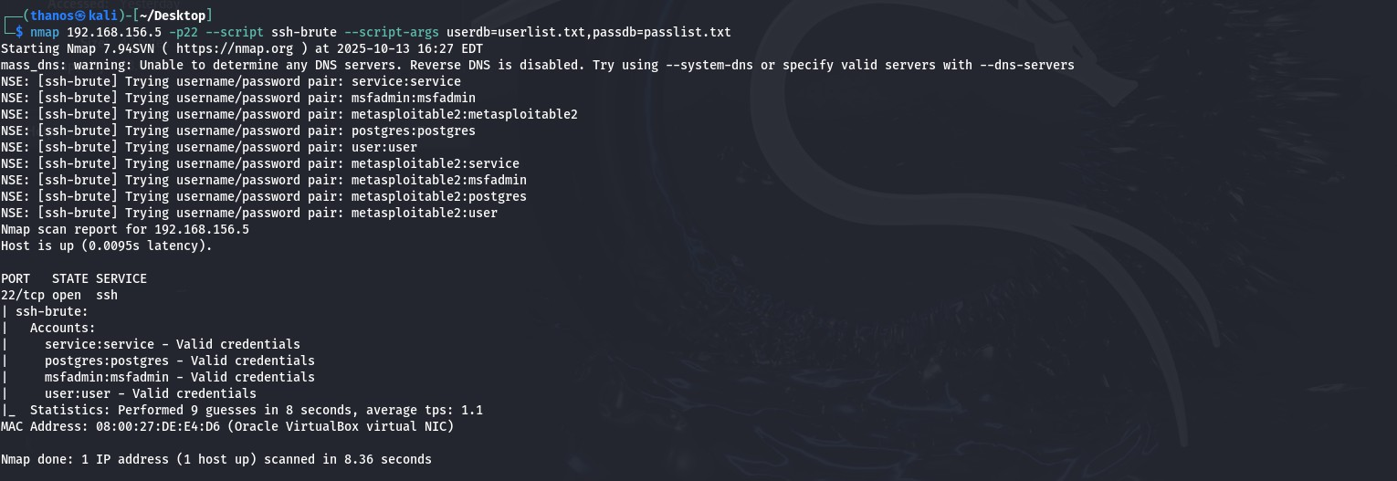

Port 25 SMTP User Enumeration
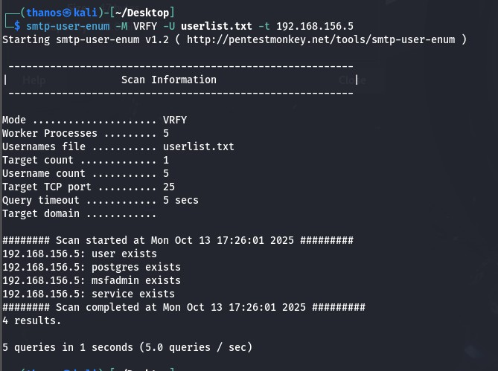
The smtp-user-enum tool is being used to quickly check for valid user accounts on an email server by sending VRFY commands to the target IP, revealing four existing usernames: user, postgres, msfadmin, and service.
Telnet Exploitation
- Connecting to Metasploitable using default credentials
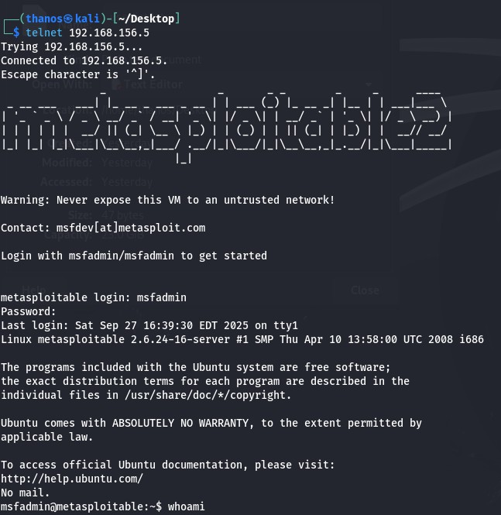

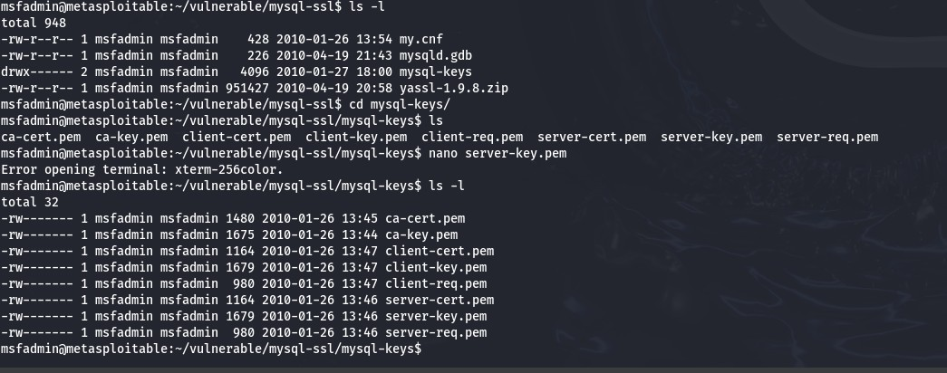
- Listing the mysql-keys directory, showing PEM files (CA, server, client) and exposing private keys and certificates.

